EPIC 02
Spring Boot Microservices Foundation
Final Implementation & Learning Documentation

Project Area | Spring Boot Microservices Foundation
Scope | JIRA 01 to JIRA 05
Primary Outcome | Production-structured, validated and testable microservices
Prepared For | Team Lead Review

This document summarizes the implementation work completed, architectural improvements made, and key technical learning achieved during EPIC 02.

1. Executive Summary
EPIC 02 focused on moving from a basic Spring Boot application to a production-structured microservice foundation. The work was completed through five JIRA tasks covering service structure, DTO-based APIs, validation, centralized exception handling, configuration profiles, environment separation, service boundaries, and a basic multi-microservice architecture.
The major objective was not simply to make APIs work, but to improve how the application is structured, protected, configured, tested, and prepared for independent service ownership and deployment.

Key Achievements
- Established a clean Controller → Service → Repository architecture.
- Implemented database entities and persistence using Spring Data JPA.
- Introduced Request and Response DTOs to prevent direct entity exposure.
- Added Bean Validation for incoming API requests.
- Implemented custom exceptions and centralized global exception handling.
- Standardized error responses and appropriate HTTP status handling.
- Migrated configuration from application.properties to YAML-based configuration.
- Implemented Development, Test, and Production Spring profiles.
- Used environment-aware configuration to reduce hard-coded environment differences.
- Built and tested a second microservice and established service boundaries.
- Validated a basic multi-microservice architecture with independent service responsibilities.
- Used Actuator health checks and API testing to demonstrate working services.

2. EPIC Scope and Completion Criteria
The completed work addressed the following EPIC-level capabilities:
- Spring Boot microservice fundamentals
- Creating a microservice from scratch
- Controller → Service → Repository architecture
- Entity vs DTO and Request/Response DTO design
- Bean validation
- Global exception handling
- HTTP status codes
- Spring Boot profiles and environment variables
- Database-per-service and service ownership
- Independent service deployment concepts
- Actuator health checks
- Basic microservice testing

3. JIRA 01 — Production-Structured Spring Boot Microservice
Objective: Create a clean, maintainable Spring Boot microservice foundation with a production-oriented package structure and REST API flow.
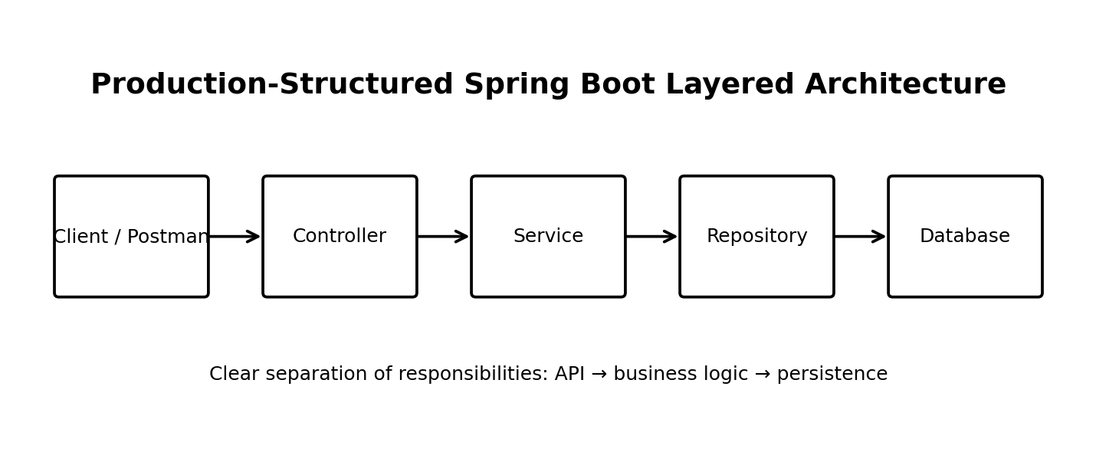

Implementation Completed
- Created the Spring Boot project using the required web, persistence, validation, database-driver, Lombok, and Actuator capabilities.
- Organized the application into dedicated controller, service, repository, entity, DTO, exception, and configuration responsibilities.
- Implemented the User domain with the required persistence fields.
- Created repository-based database operations.
- Implemented service-layer operations for create, retrieve, update, and delete workflows.
- Exposed REST endpoints for the User resource and verified API behaviour through Postman.

Result
The application moved from a simple application structure to a layered design where web concerns, business logic, and database access are separated. This makes the service easier to understand, test, modify, and scale.

4. JIRA 02 — DTOs, Validation & Global Exception Handling
Objective: Improve API professionalism by separating external API contracts from internal database entities and by returning consistent validation and error responses.
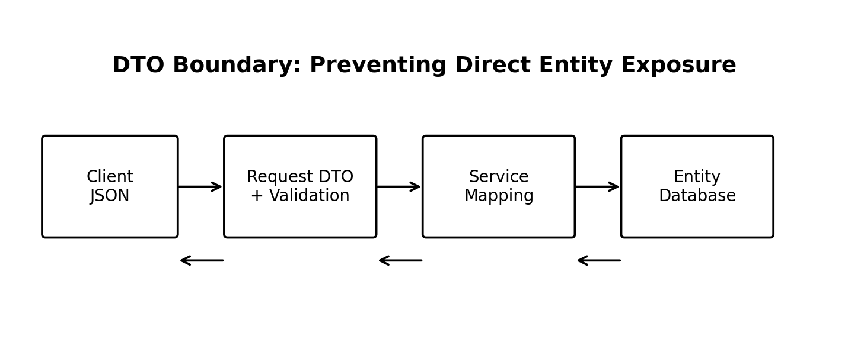

DTO Improvements
- Created CreateUserRequest for user creation input.
- Created UpdateUserRequest for controlled update input.
- Created UserResponse for outgoing API responses.
- Removed direct exposure of persistence entities from controller responses.
- Introduced explicit request/response boundaries between clients and internal data models.

Validation Improvements
Bean Validation was introduced using annotations such as:
- @NotBlank
- @NotNull
- @Email
- @Size
- @Pattern
Validation was applied to relevant request data such as name, email, phone, and password so invalid input can be rejected before it reaches core business logic.
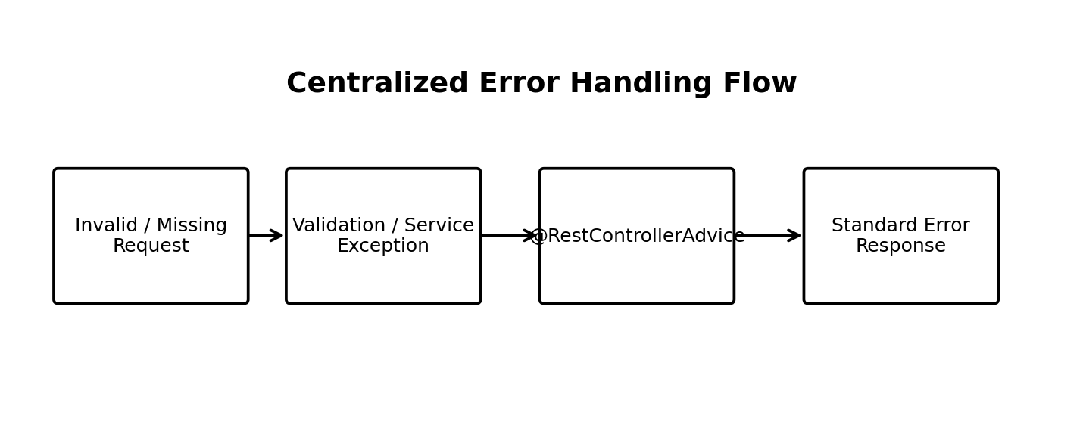

Exception Handling Improvements
- Created domain-specific exceptions including UserNotFoundException, DuplicateEmailException, and InvalidUserException.
- Implemented centralized handling using @RestControllerAdvice.
- Handled validation failures, missing resources, duplicate data, and generic exceptions.
- Returned standardized error information including timestamp, HTTP status, error/message information, and request path.
This removed scattered error handling and made API failure behaviour predictable for API consumers.

5. JIRA 03 — Spring Boot Configuration & Environment Profiles
Objective: Separate application configuration by environment and make the service easier to run in development, testing, and production scenarios.
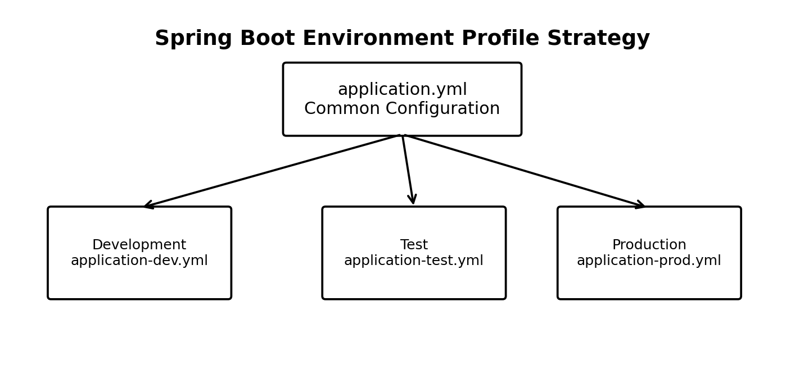

Configuration Changes
- Converted the main configuration approach from application.properties to application.yml.
- Separated environment-specific settings into Development, Test, and Production profiles.
- Used a common configuration structure with profile-specific overrides.
- Improved environment awareness by supporting environment-based configuration rather than treating every deployment identically.
- Prepared the application for safer and clearer deployment configuration.

Why This Was an Important Improvement
Profile separation prevents development-oriented configuration from automatically becoming production configuration. It also makes test execution more controlled and supports the principle that configuration should be externalized and environment-specific.

6. JIRA 04 — Second Microservice & Service Boundaries
Objective: Move beyond a single-service application and demonstrate the core idea of microservice separation: each service owns a focused responsibility and should avoid becoming tightly coupled to another service's internal implementation.
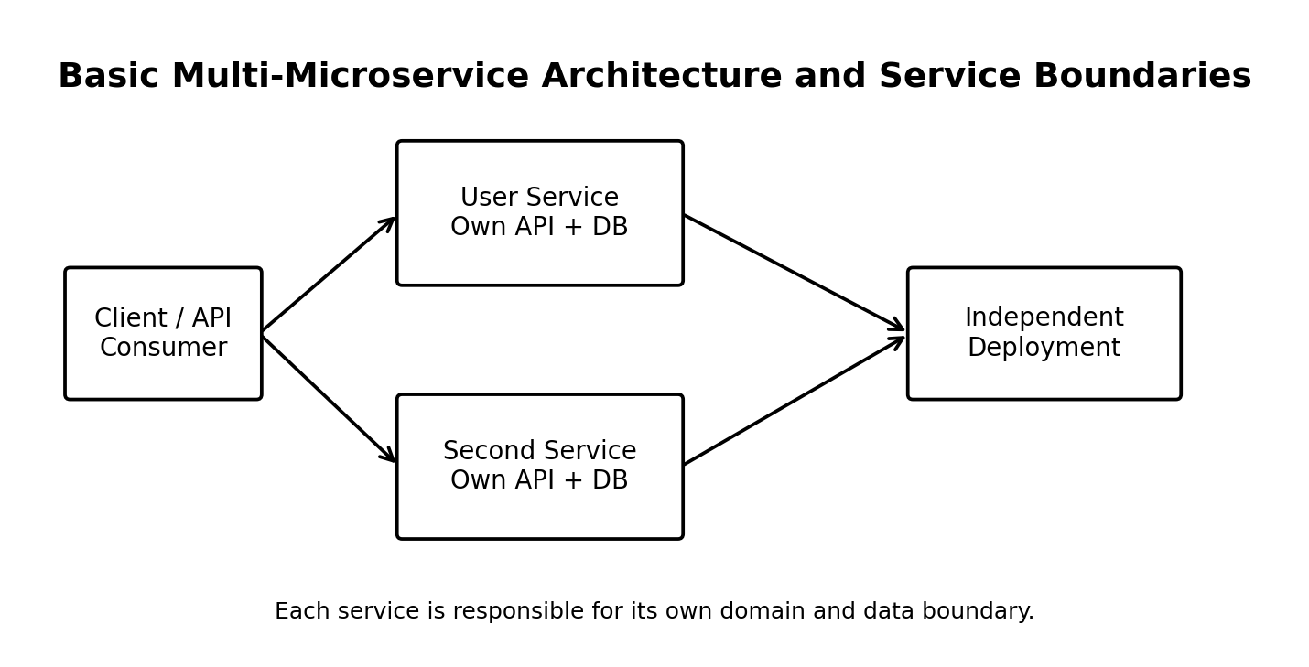

Architecture Understanding Achieved
- Built and worked with a second microservice as part of the EPIC architecture.
- Defined service boundaries instead of treating multiple domains as one large application.
- Applied the database-per-service and service ownership concepts.
- Understood that services should communicate through explicit interfaces rather than direct access to another service's internal layers.
- Validated the concept of independently running and deploying services.

7. JIRA 05 — Basic Multi-Microservice Architecture
Objective: Build and test a basic architecture containing more than one microservice and verify that services can operate according to their individual responsibilities.

What Was Demonstrated
- Multiple Spring Boot services were included in the architecture.
- Each service retained a clear ownership boundary.
- Core service APIs were tested as part of the overall implementation.
- Basic multi-service behaviour and independent service execution were validated.
- Health and application availability concepts were supported using Spring Boot Actuator.

Testing Approach
- Successful API requests.
- Invalid request payloads.
- Missing resource scenarios.
- Duplicate email scenarios.
- Invalid identifier scenarios.
- Validation error responses.
- HTTP status code verification.
- Actuator health verification.

8. API Design and Quality Improvements
The final application is more production-oriented than the initial implementation because the API contract, persistence model, business logic, validation, error handling, and configuration are now separated into focused responsibilities.
Area | Earlier / Basic Approach | Improved EPIC 02 Approach
Architecture | Basic API implementation | Layered Controller → Service → Repository structure
API Data | Entity can be exposed directly | Request and Response DTO boundaries
Validation | Manual or limited validation | Bean Validation at request boundary
Errors | Scattered / inconsistent handling | Centralized @RestControllerAdvice
Configuration | Single properties-based setup | YAML with dev, test, and prod profiles
Scalability | Single-service mindset | Service boundaries and multi-microservice structure
Operations | Limited runtime visibility | Actuator health awareness
Testing | Happy-path focus | Success and negative-path API testing

9. Key Technical Learning
- A Spring Boot microservice is not defined only by having REST APIs; maintainable architecture and service boundaries are equally important.
- Controllers should focus on HTTP request/response handling rather than business logic.
- Service classes are the correct place for business rules and orchestration.
- Repositories isolate persistence access from the rest of the application.
- Entities are database models and should not automatically become public API contracts.
- DTOs provide security, flexibility, and a stable API contract.
- Validation should happen as close as possible to the API boundary.
- Centralized exception handling creates a consistent client experience.
- HTTP status codes are part of the API contract and should accurately represent outcomes.
- Profiles are essential for separating development, test, and production behaviour.
- Externalized configuration reduces environment-specific code changes.
- Microservices require clear ownership boundaries and independent responsibility.
- Database-per-service reduces unnecessary coupling between services.
- Health checks and testing are important for demonstrating that a service is operational.

10. Final Architecture Summary
The final EPIC 02 implementation can be understood as the following progression:
- Step 1: Build a working Spring Boot service.
- Step 2: Organize it into clean architectural layers.
- Step 3: Protect API boundaries with DTOs.
- Step 4: Validate incoming data.
- Step 5: Centralize and standardize failures.
- Step 6: Separate configuration by environment.
- Step 7: Add another service and define boundaries.
- Step 8: Test the resulting multi-microservice foundation.

11. Conclusion
EPIC 02 successfully established a strong Spring Boot microservices foundation. The implementation progressed from basic CRUD functionality to a cleaner and more professional architecture with DTO-based APIs, request validation, global exception handling, standardized error responses, YAML configuration, environment profiles, service boundaries, and basic multi-microservice testing.
The most important outcome of this EPIC was the improvement in engineering approach. The application is now structured around separation of concerns, controlled API contracts, predictable failure handling, environment-aware configuration, and independent service responsibility. These practices provide a solid foundation for future microservice development and more advanced distributed-system capabilities.

12. Deliverables Completed
- Working Spring Boot microservice foundation.
- Clean package structure.
- CRUD REST APIs.
- Database integration.
- Request and Response DTOs.
- Bean validation.
- Custom exceptions.
- Global exception handler.
- Standard error responses.
- YAML configuration.
- Development, Test, and Production profiles.
- Environment-aware configuration.
- Second microservice and service boundaries.
- Basic multi-microservice architecture testing.
- Actuator health checks.
- Postman/API test evidence.
- Final technical documentation.

